A Project Report On

Smart Retail Management System

Submitted in partial fulfillment of the requirement for the BCA Semester-4 Python Programming Subject Final Examination.
BACHELOR OF COMPUTER APPLICATIONS
(B.C.A.)

Academic Year 2025 – 26

Saurabh Kumar- (92400527352)

Internal Guide
KISHITA DOSHI



Rajkot-Morbi Road, At & PO : Gauridad, Rajkot 360 003. Gujarat. India.
CONTENTS

Chapters | Particulars | Page No.
1 | SYNOPSIS | 4
2  2.1  2.2  2.3  2.4 | PREAMBLE  General Introduction  Statement of Problem  Objective and Scope of the Study  Module Description with functionality | 4  4  4  5  5
3  3.1  3.2  3.3  3.4 | SYSTEM DESIGN AND DEVELOPMENT  Data Flow Diagram (DFD)  Table Structure  Menu Design  Screen Design (Screen shots with short description) | 6  6,7,8  8  9  10
4 | CONCLUSION | 11
5 | LEARNING DURING PROJECT WORK | 11
6  6.1  6.2 | BIBLIOGRAPHY  Online References  Offline References | 12  12  12

FIGURE INDEX

Sr. No. | Figure No. | Particulars | Page No.
1 | 1 | Level 0 DFD (Context Diagram) | 6
2 | 2 | Level 1 DFD | 7
3 | 3 | Entity Relationship Diagram (ERD) | 8
4 | 4 | Login Screen | 10
5 | 5 | Main Dashboard Screen | 10

TABLE INDEX

Sr. No. | Table No. | Particulars | Page No.
1 | 1 | Users | 8
2 | 2 | Products | 8
3 | 3 | Sales | 9

1.SYNOPSIS

The Smart Retail Management System is a desktop-based software application developed to simplify and automate daily operations of a retail shop. It helps shop owners manage products, billing, and sales records efficiently. The system is developed using Python programming language, Tkinter for GUI, and MySQL for database storage.
In traditional retail shops, product details and billing are maintained manually using notebooks or calculators. This leads to errors, data loss, and difficulty in tracking sales. This project solves these problems by providing a digital solution where users can easily add, update, search, and delete product details. The system automatically calculates the total bill amount based on product price and quantity, reducing manual calculation errors.
The application also generates a PDF invoice for customers and allows bill details to be shared through WhatsApp. It stores customer details such as name and mobile number, helping maintain sales history. Additionally, the system provides sales reports and graphical representation using charts. A low stock alert feature helps identify products that need restocking.

2.PREAMBLE
2.1 General Introduction

In today’s digital world, computer-based systems are widely used to manage business activities efficiently. Retail shops handle multiple daily operations such as maintaining product records, generating bills, managing stock, and tracking sales performance. When performed manually, these tasks require more time and effort and may lead to errors.
The Smart Retail Management System provides an automated solution for retail shop operations. It helps shopkeepers maintain product details, generate bills, store customer information, and track sales data accurately. The application uses Python (simple and powerful), Tkinter (user-friendly GUI), and MySQL (secure data storage). It also integrates PDF generation (Reportlab) and WhatsApp sharing.
This software reduces manual work, improves efficiency, and helps shop owners maintain accurate records. It is especially useful for small retail shops.

2.2 Statement of Problem

In many small retail shops, the following problems exist:
- Difficulty in maintaining product records properly
- High chances of calculation mistakes in billing
- Time-consuming process for creating bills manually
- Difficulty in tracking stock availability
- No proper record of customer purchase history
- Difficulty in generating sales reports
- Risk of losing important data
Because of these problems, shopkeepers face difficulties in managing their business effectively. This project solves these problems by providing an automated system.
2.3 Objective and Scope of the Study
Objectives:
- To develop an easy-to-use retail management software
- To manage product details (name, price, quantity)
- To generate bills automatically using product price and quantity
- To reduce manual calculation errors
- To store customer details for future reference
- To generate sales reports for business analysis
- To display graphical representation of sales data
- To send bill details to customers via WhatsApp
- To provide a low stock alert feature for inventory management
Scope:
The scope is limited to small and medium retail shops. The system can be used for:
- Managing inventory or stock
- Recording daily sales transactions
- Generating customer bills quickly
- Maintaining customer purchase records
- Viewing sales performance through reports and graphs
- Identifying low stock products
The system is desktop-based. Future scope includes barcode scanning, online payment, cloud storage, AI sales prediction and mobile app support.

2.4 Module Description with Functionality
The system has eight modules:

Module | Functions
1. Login | Register new account, login with username/password, check credentials from database, prevent unauthorized access
2.Product Management | Add new product (id, name, price, quantity), update quantity, delete product, search by name, view all products
3. Billing | Enter customer name, mobile, select product, enter quantity → auto total = Price × Quantity, reduce stock, save sales record
4.WhatsApp Integration | Create message with bill details, open WhatsApp Web link automatically
5. Report | View all sales records (customer name, product, quantity, total, date)
6. Dashboard | Show total number of products and total revenue generated
7. Low Stock Alert | Display products with quantity less than minimum level (e.g., < 5)
8. Graph | Display bar chart of product sales using Matplotlib library
3.SYSTEM DESIGN AND DEVELOPMENT
3.1 Data Flow Diagram (DFD)

Level 0 DFD (Context Diagram)
The entire system is shown as a single process.
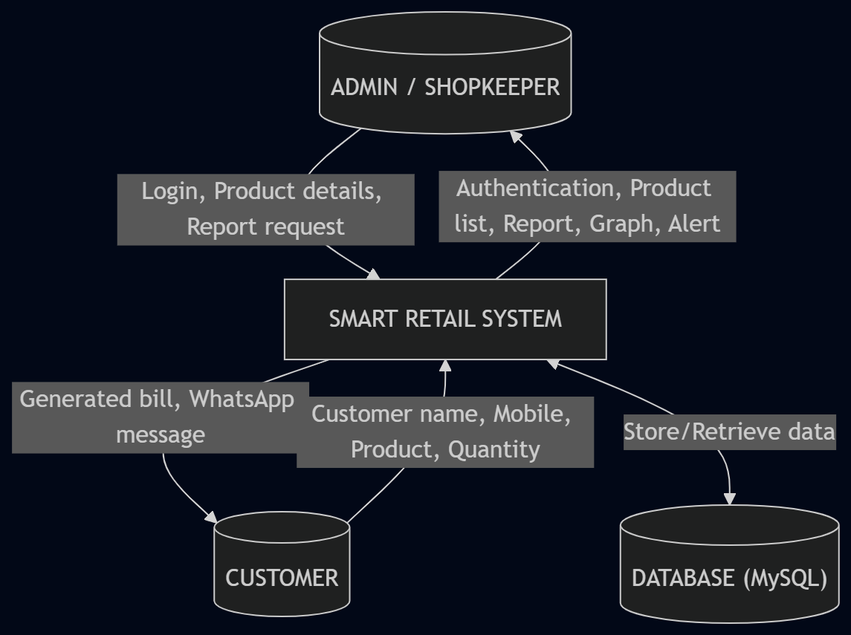

Level 1 DFD
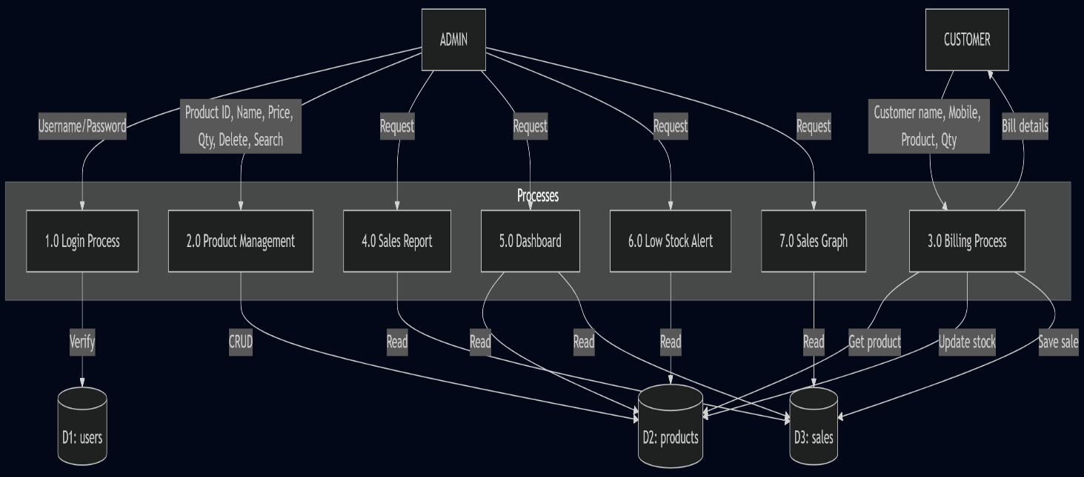

Entity Relationship Diagram (ERD)
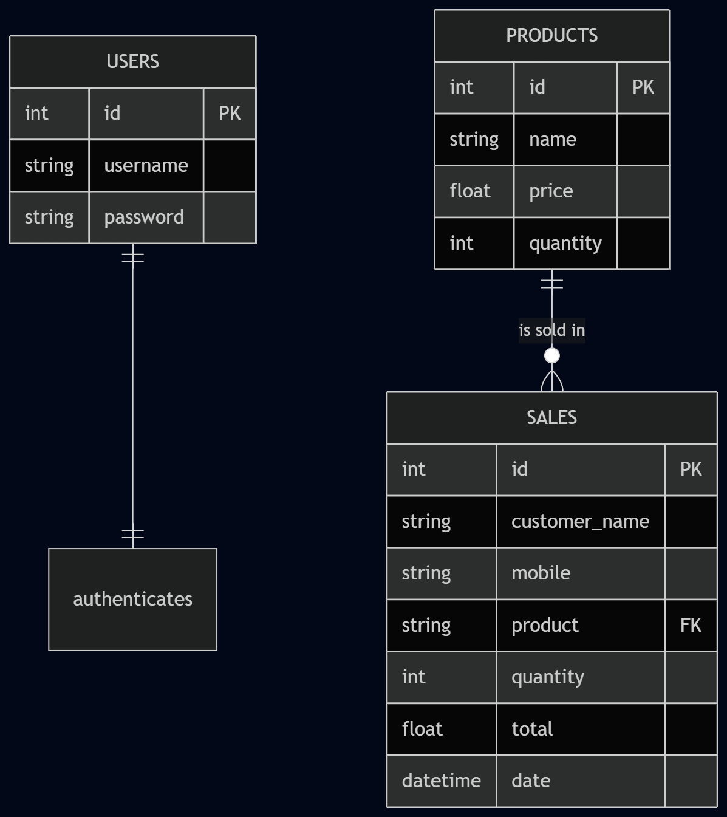

3.2 Table Structure

Table 1: users

Field | Data Type | Constraint
id | int | PRIMARY KEY, AUTO_INCREMENT
username | varchar(50) | NOT NULL
password | varchar(255) | NOT NULL

Table 2: products

Field | Data Type | Constraint
id | int | PRIMARY KEY, AUTO_INCREMENT
name | varchar(100) | NOT NULL
price | float | NOT NULL
quantity | int | NOT NULL, DEFAULT 0
Table 3: sales

Field | Data Type | Constraint
id | int | PRIMARY KEY, AUTO_INCREMENT
customer_name | varchar(100) | NOT NULL
mobile | varchar(15) | NOT NULL
product | varchar(100) | FOREIGN KEY (references products.name)
quantity | int | NOT NULL
total | float | NOT NULL
date | datetime | DEFAULT CURRENT_TIMESTAMP

3.3 Menu Design

Main menu options (as seen in the dashboard):

Button | Function
Add Product | Insert new product into database
Delete ID | Remove product by ID
Search | Find product by name
View Products | Display all products
Generate Bill | Create bill, update stock, save sale
Sales Report | Show all transactions
Dashboard | Show totals
Low Stock Alert | List low stock items
Sales Graph | Show bar chart

3.4 Screen Design

Figure 1: Login Screen
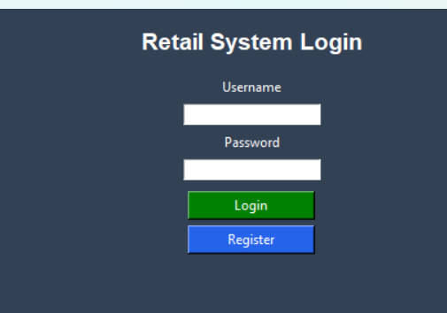

Figure 2: Main Dashboard Screen
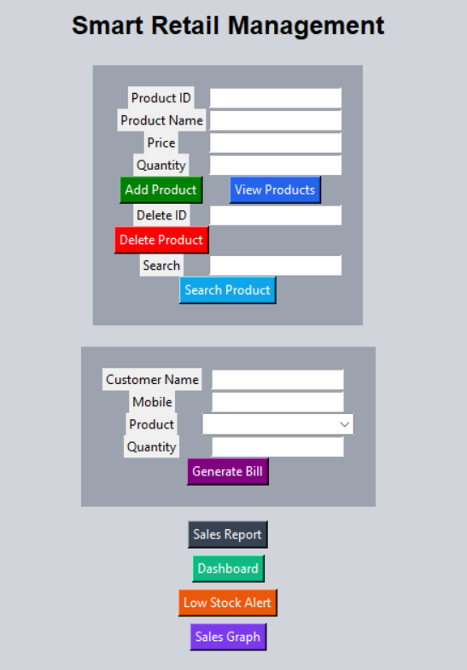
4.CONCLUSION

The Smart Retail Management System successfully achieves its objectives. It provides an easy-to-use interface for managing products, generating bills, and tracking sales. The automatic bill calculation reduces errors, and the database storage ensures data safety. The WhatsApp integration and PDF invoice features add convenience for customers. Sales reports and graphs help shop owners analyze performance. Low stock alerts prevent inventory shortages. Overall, the system saves time, improves accuracy, and enhances retail business management.

5.LEARNING DURING PROJECT WORK

During this project, I learned:
- Python Programming: Advanced concepts like functions, classes, exception handling, and file handling.
- Tkinter GUI Development: Creating windows, frames, labels, entry boxes, buttons, and event binding.
- Database Connectivity: Using mysql-connector to connect Python with MySQL, executing queries, and handling results.
- CRUD Operations: Implemented Create, Read, Update, Delete for product and sales records.
- Data Flow Diagram (DFD): Designed Level 0 and Level 1 DFD to visualize system processes.
- Entity Relationship Diagram (ERD): Designed database relationships and cardinalities.
- PDF Generation: Used Reportlab library to generate professional invoices.
- WhatsApp Integration: Used webbrowser module to open WhatsApp Web with pre-filled messages.
- Data Visualization: Used Matplotlib to create bar charts for sales analysis.
- Project Documentation: Learned to write synopsis, preamble, objectives, modules, and conclusions

6. BIBLIOGRAPHY

6.1 Online References

1. ChatGPT
- Deepseek

6.2 Offline References :

1. Python Programming Notesbook

